**TERRAFORM – POC**

Installing aws cli and configuring

AWS configure

Providing credentials region and output types

1. **Create Two Resources in Different Regions**

Here’s how you can create two resources, such as EC2 instances, in different regions

Provider.tf

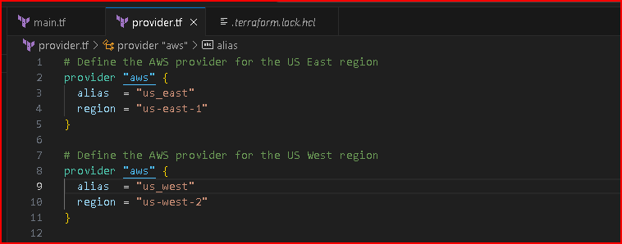

Main.tf

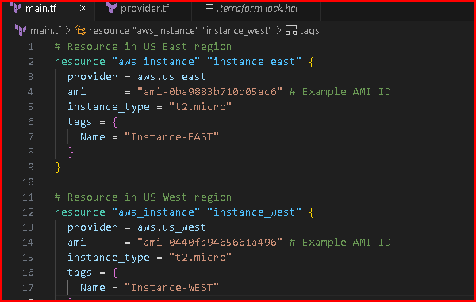

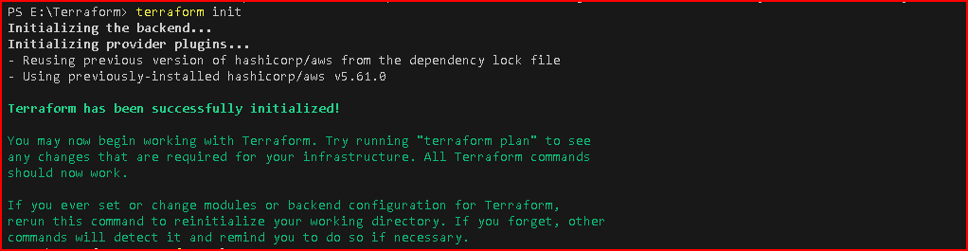

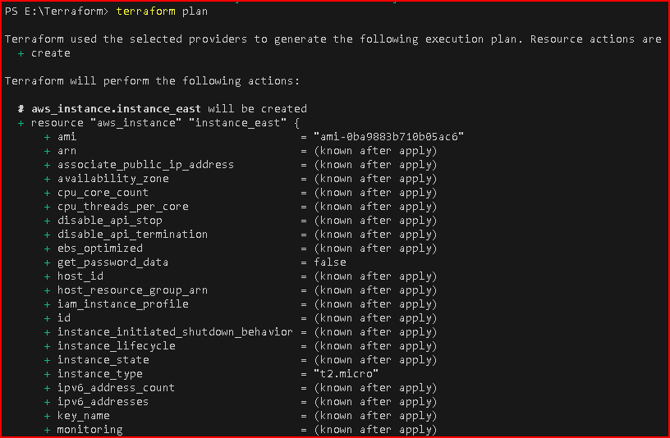

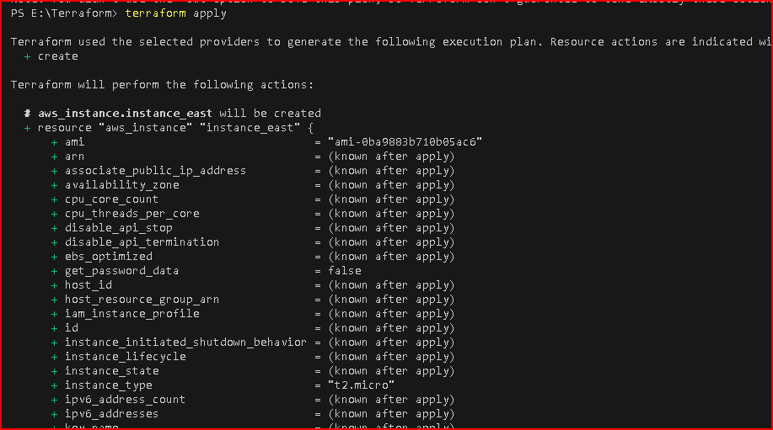

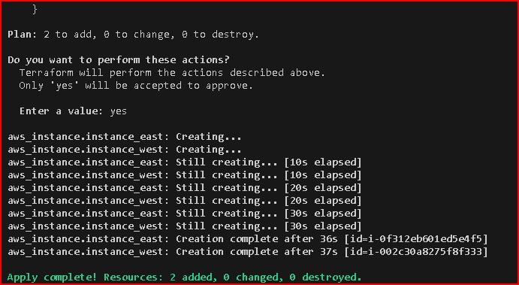

Successfully created resources within two different regions

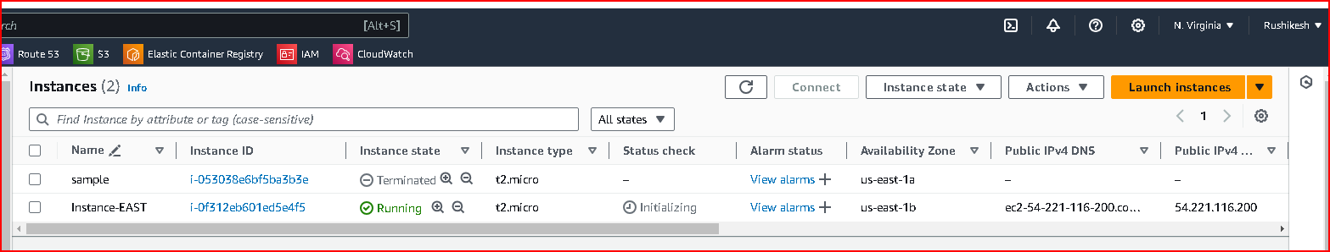

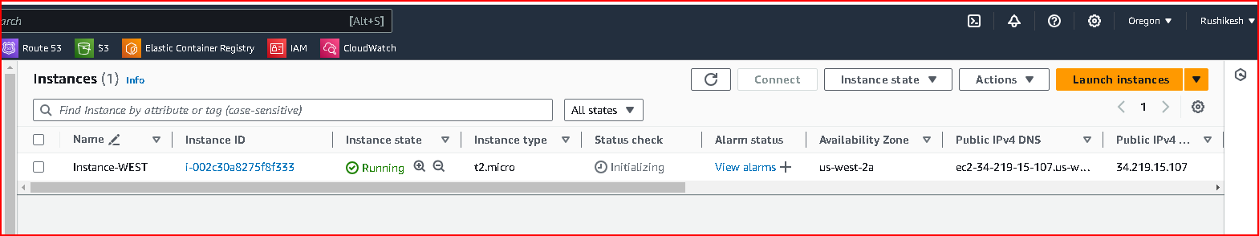

1. **Perform state lock**

Creating S3 bucket

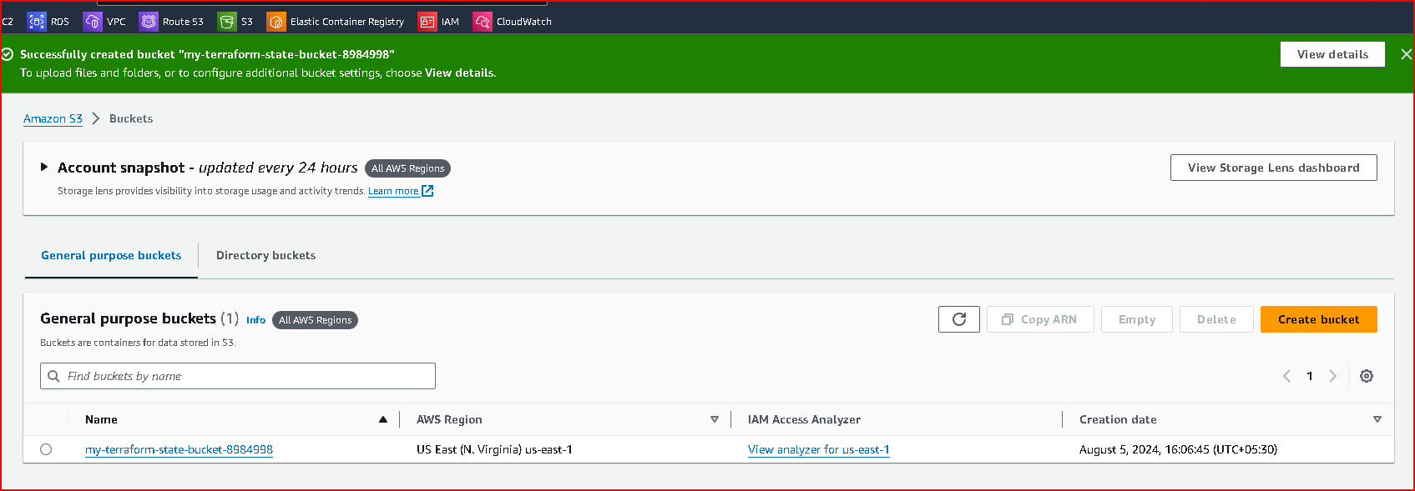

Creating dynamoDB table

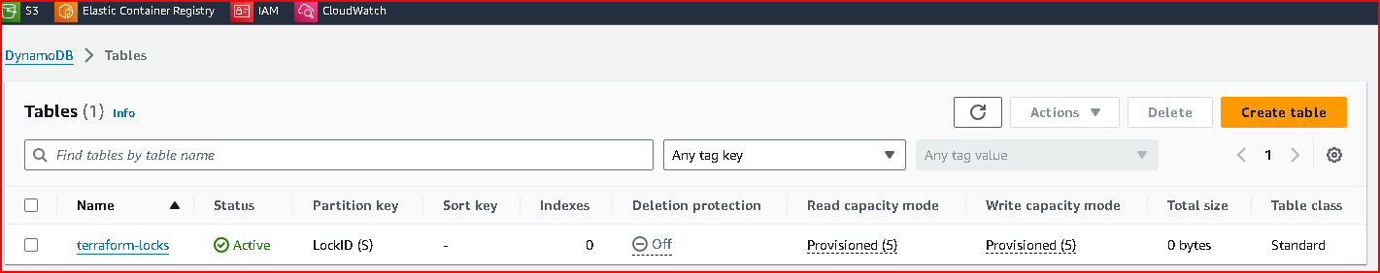

Initializing backend to store state

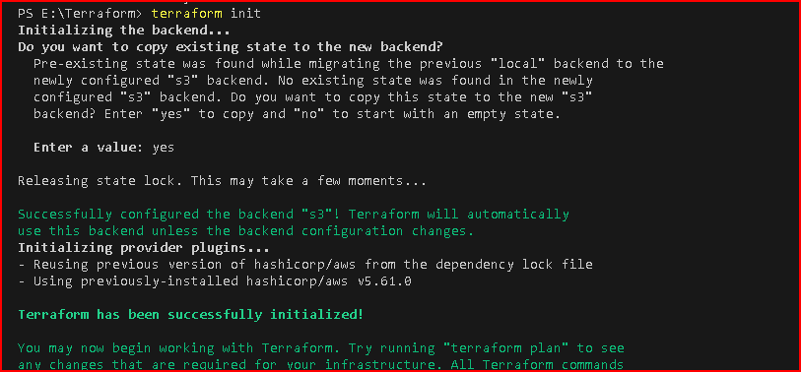

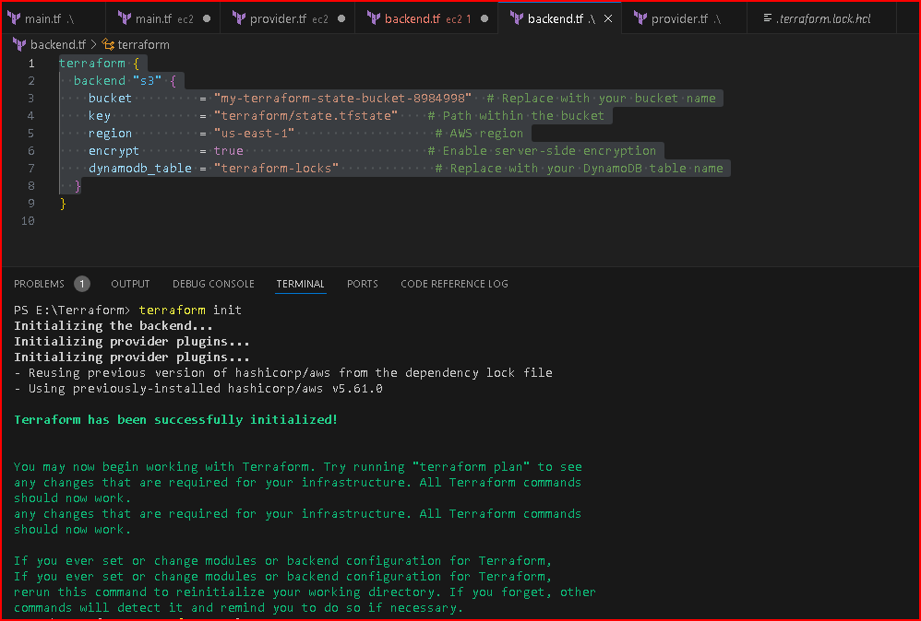

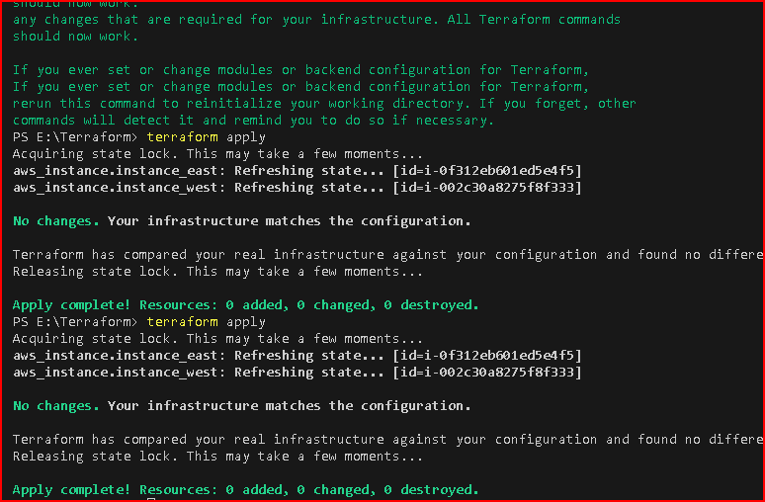

created new terraform project state lock with similar codes and Backend to store statefile

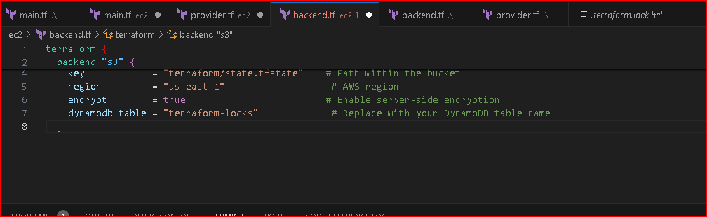

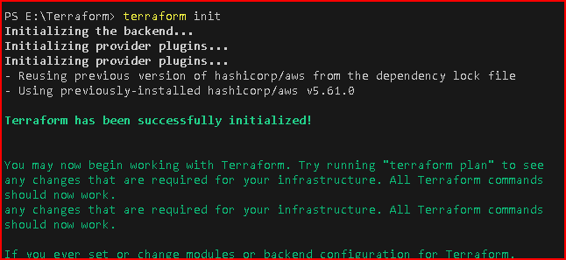

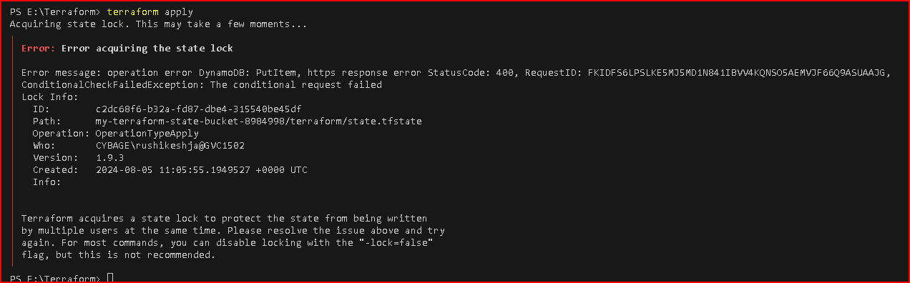

1. **Create 3 identical resources with different name using loops.**

provider.tf: Configures the AWS provider with the desired region i.e “us-east-1”

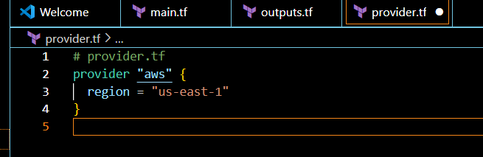

main.tf:

* 1. variable "instance_count": Defines the number of instances to create.
  2. variable "instance_names": Defines the names for each instance.
  3. resource "aws_instance" "example": Uses the count meta-argument to create multiple instances. The count.index is used to index into the instance_names variable to assign unique names.

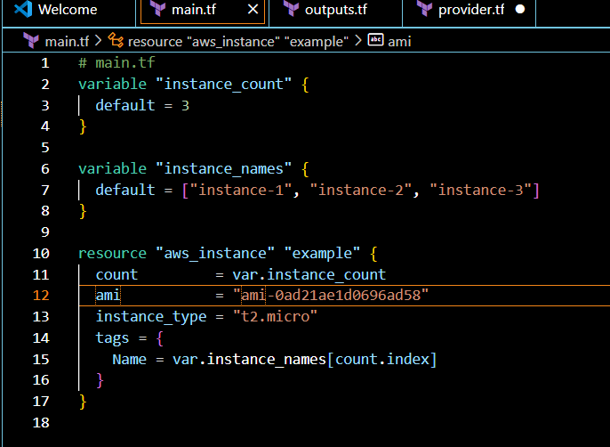

outputs.tf:

output "instance_ids": Outputs the IDs of the created instances.

output "instance_public_ips": Outputs the public IP addresses of the created instances.

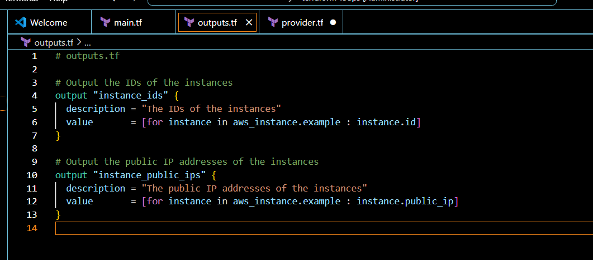

successfully executing following commands

Terraform init-

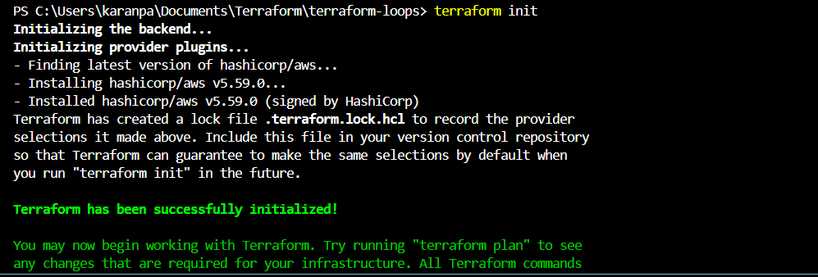

Terraform plan

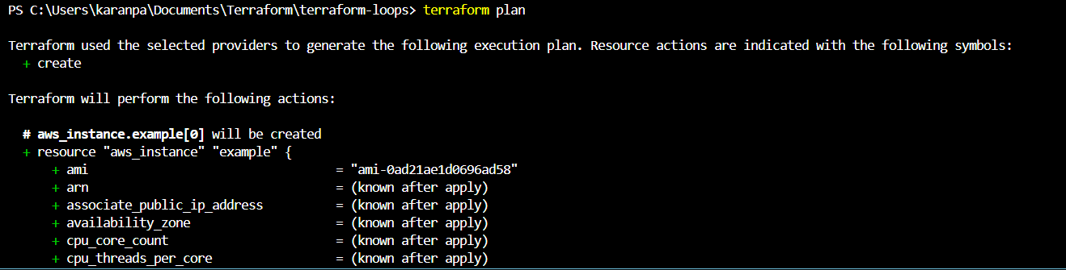

Terraform apply with outputs

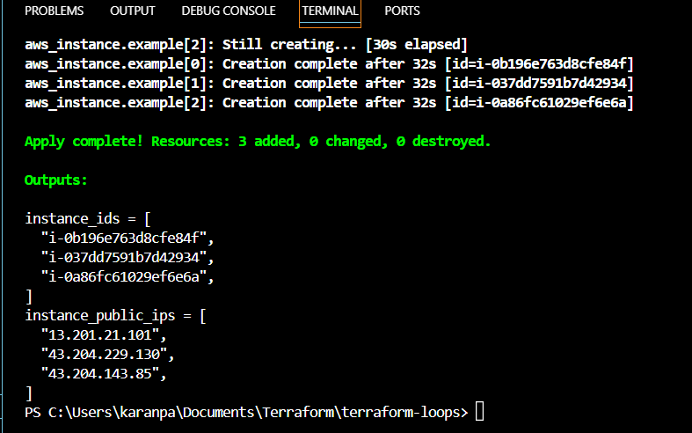

1. **Deploy 3-tier application using terraform**
   1. Set up environment: Install Terraform and AWS CLI.
   2. Create directory structure: Organize Terraform files.

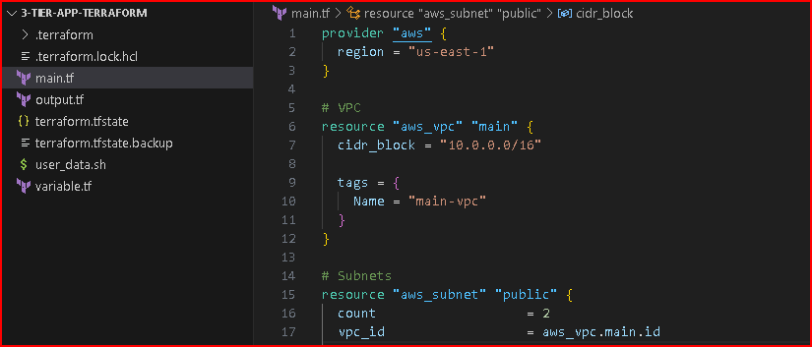

* 1. Write configuration: Define provider, variables, resources, and outputs.

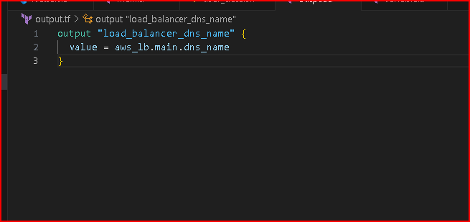

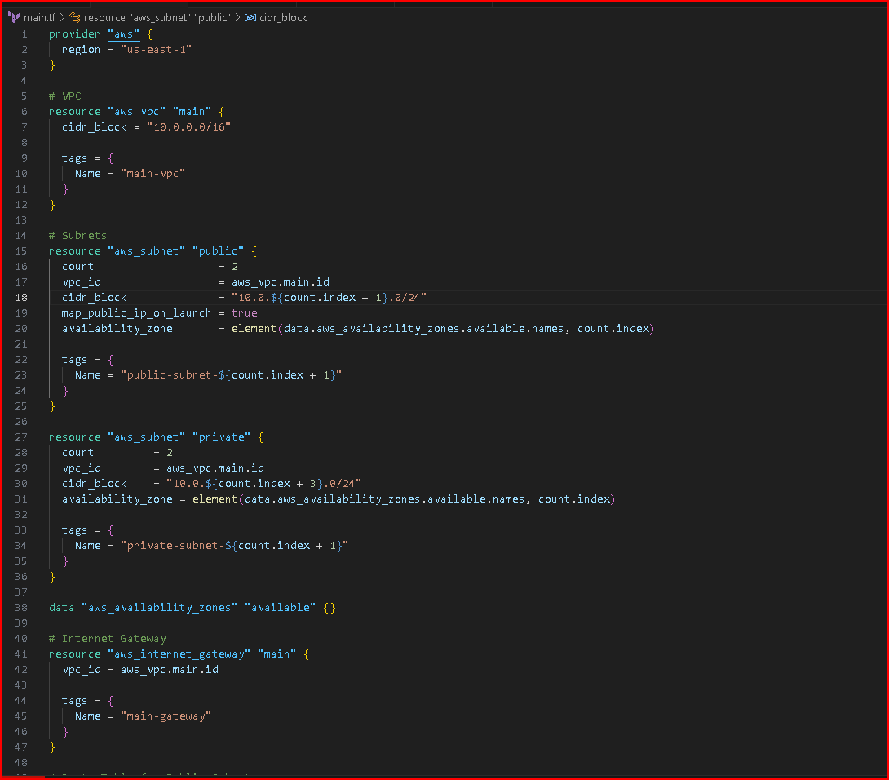

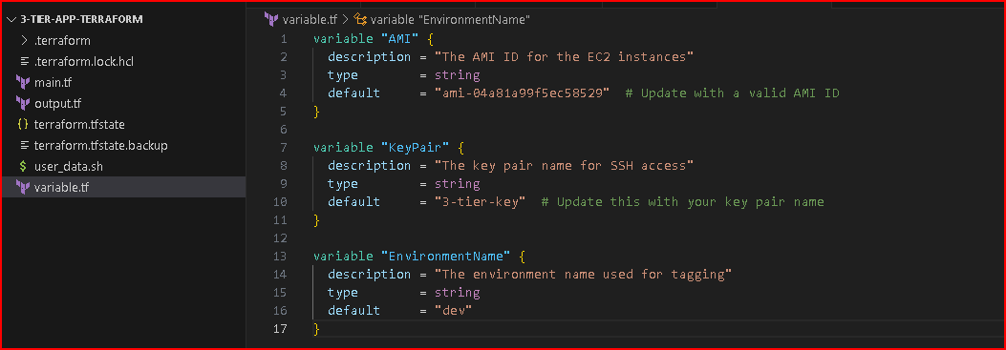

* 1. Initialize and apply: Use Terraform commands to deploy and verify resources.

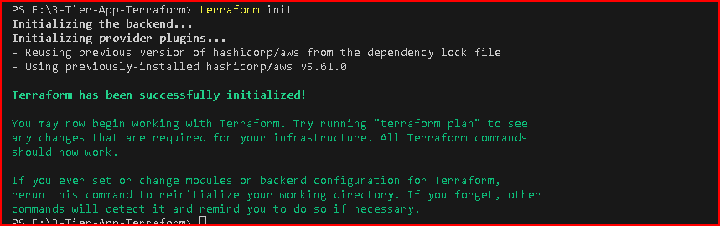

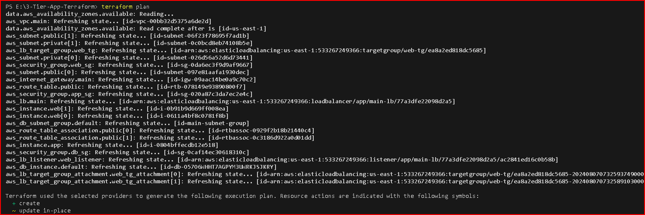

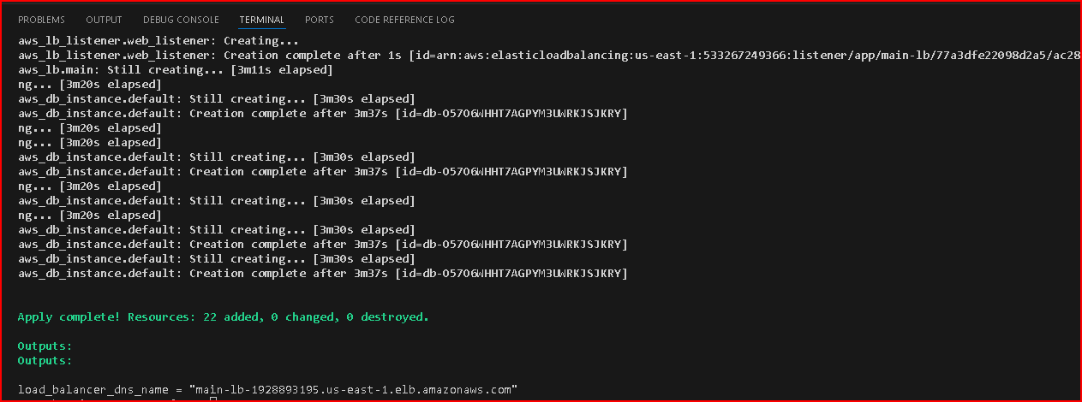

* 1. Copy LB dns and hit

<http://main-lb-1928893195.us-east-1.elb.amazonaws.com/>

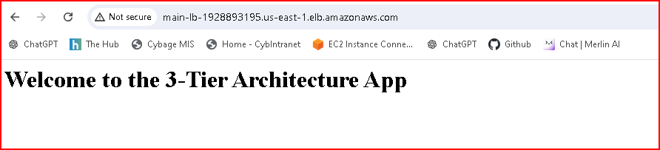

* 1. Clean up: Destroy resources when no longer needed.

